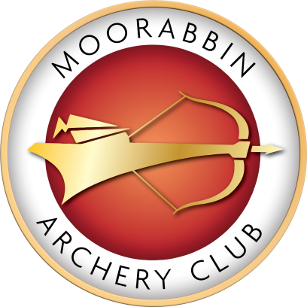
Congratulations
on the completion of your qualifying rounds.
You have shown your dedication and skills and are now eligible to enjoy a shoot when the Club is unattended.
As you have the responsibility of owning a key that will open the gate and unlock a target butt there is some information that you need to know, please read on…
These are the Rules for Responsible key ownership.
- Do not shoot further than 70m. The longer distances are to be shot in the centre of the Range not on the targets close to the Clubhouse or towards the Waves carpark.
- No High Draws by ALL bow types but especially by Compound shooters.
- Any Bow shot should not exceed 60 pound peak draw weight. If you are unsure of the peak draw weight of your bow ask to check at the Club.
- Do not shoot beyond your qualified distance.
- No Crossbows.
- Do not use Broadhead arrow points.
- If you make changes to your bow set up always recheck sight settings at shorter distances and work your way out to the longer distances.
- If you move a target butt, when you have finished shooting please return it to its correct position, then lock it and tie the side ropes firmly.
- Do not leave the gate open when in attendance and always lock the gate when you leave.
- Only shoot from the shooting line.
- Be courteous and respectful to all other shooters on the Range.
- Be safe at all times, especially when collecting arrows. Either shoot on a target away from another archer so you can collect arrows independently or shoot near them and walk to collect together. Communication is key.
- Wear correct footwear, no open toed shoes. Also wear suitable clothing for this outdoor sport includes sun protection.
- Do not shoot if there is a lightning storm, and only return to the field once the lightning has stopped for 30minutes or longer.
- Foam Target butts are for use at 50m and further back.
- Do not bring guests to the club to shoot.
- Children should be under control of the supervising adult and dogs should be on a lead at all times and also under control of the supervising adult.
- Do not consume alcohol on the grounds, and under no circumstances can you shoot while under the influence of alcohol or drugs.
- Please place your rubbish in the bins provided.

If any of these rules are broken, it may jeopardise MAC’s ability to continue operating as a club, and you may be asked to return your key.

By accepting and signing the Register for the key you are agreeing to the Rules for Responsible Key Ownership at Moorabbin Archery Club.

We the Committee thank you and acknowledge your commitment to this Club. Your behaviour in abidance of these rules is appreciated, as well as expected.

