
OzBow Certification Program Score Sheet

Name
Distance
Bow Type

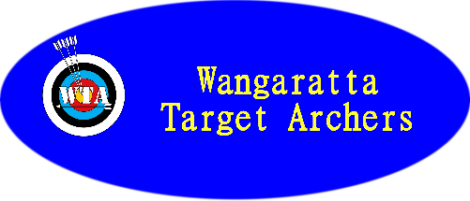
 |  |  |  |  |  |  | End Score | Accumulative Score
End 1
End 2
End 3
End 4
End 5
 |  |  |  |  |  | Distance Total

Archers  Signature: |  |  | Witness  Signature:

