Becoming an Archery Australia Member

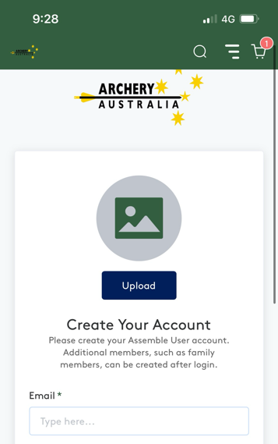
- Search in your browser for “Archery Australia Membership” or use the link https://account.archery.assemblesports.io/sign-up.
This will take you to the sign up page where you can enter your information and then create an account.

- Once you have created an account and login, you will be taken to the front dashboard page where you can see your account and any featured events. Click on the search icon on the top green bar (right side) to open the search feature.
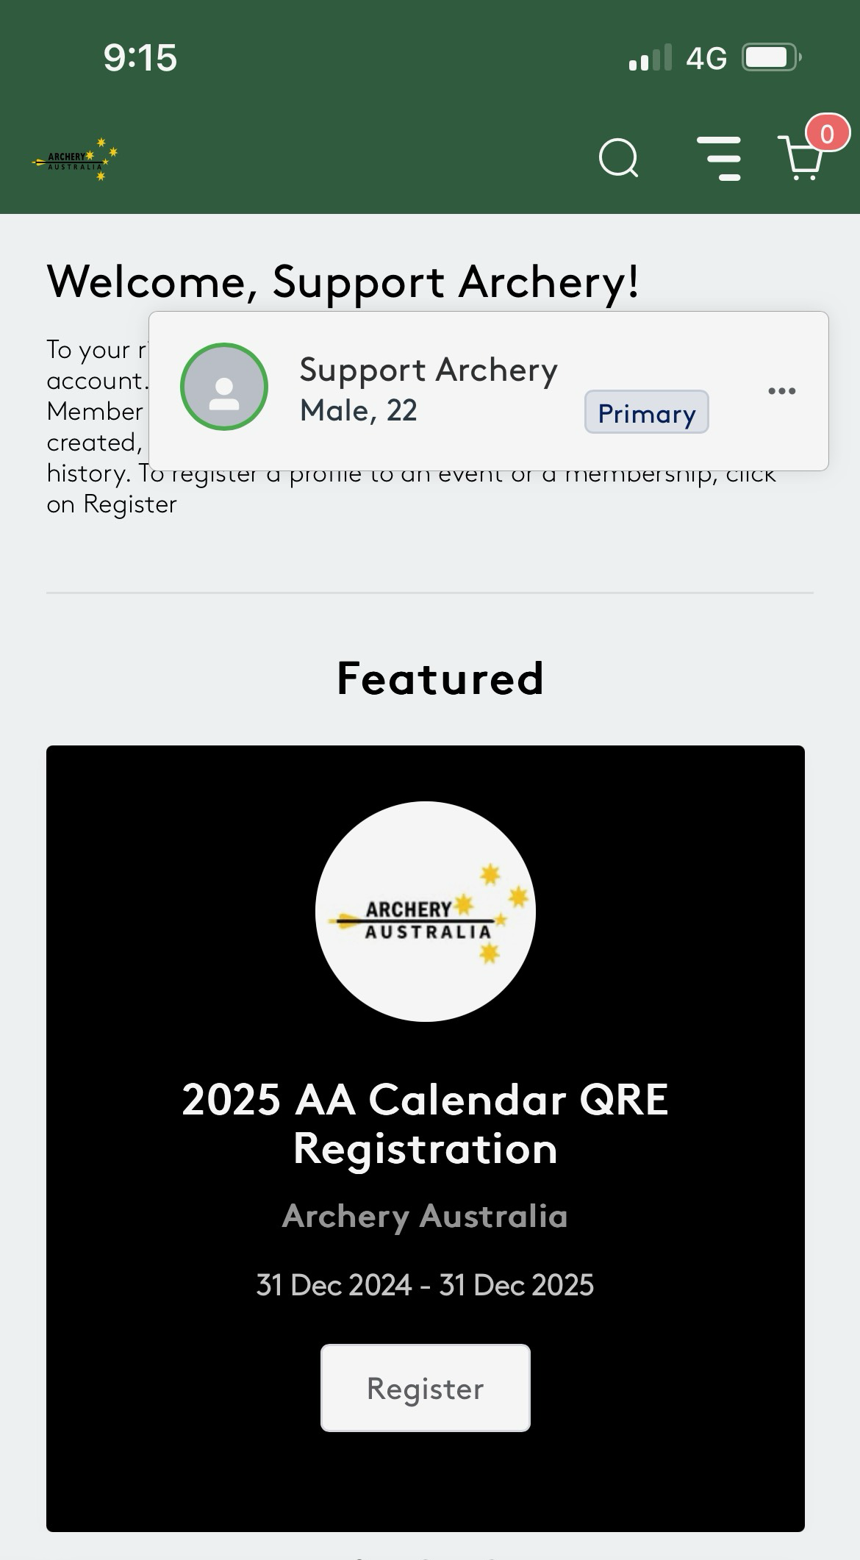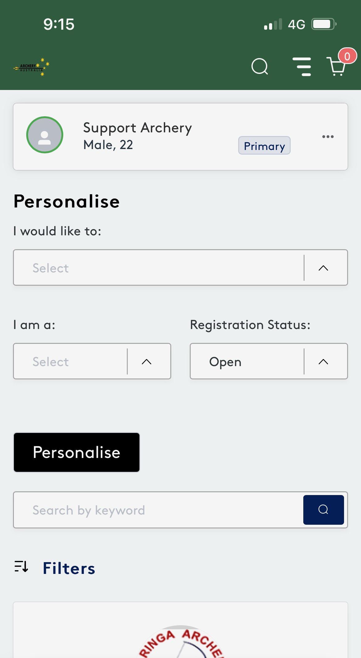

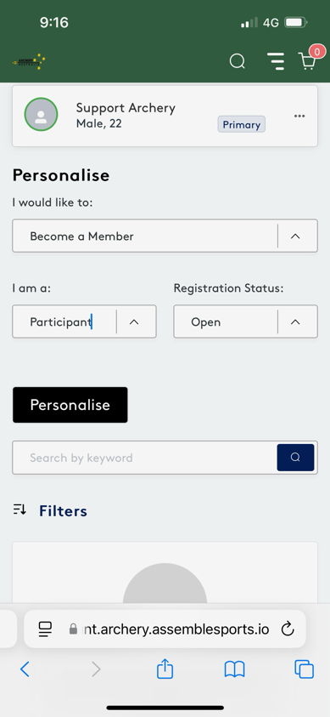
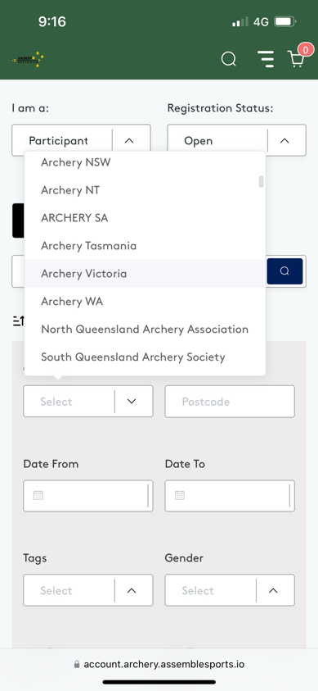
- Use the personalise feature to find what you are looking for. Please fill all 3 boxes depending on your search desires. To narrow down your search while looking for memberships or events, use the filter option to filter by state or club specifically. You can also use the “Search by keyword” area to find memberships by specific words or names.

- Scroll down to find the desired membership, click on the black “Register” icon which will open the registration options for the membership (some clubs have age categories setup in their membership). Then click on the desired membership. Some clubs have an approval process for new members, please see below right screenshot for example.
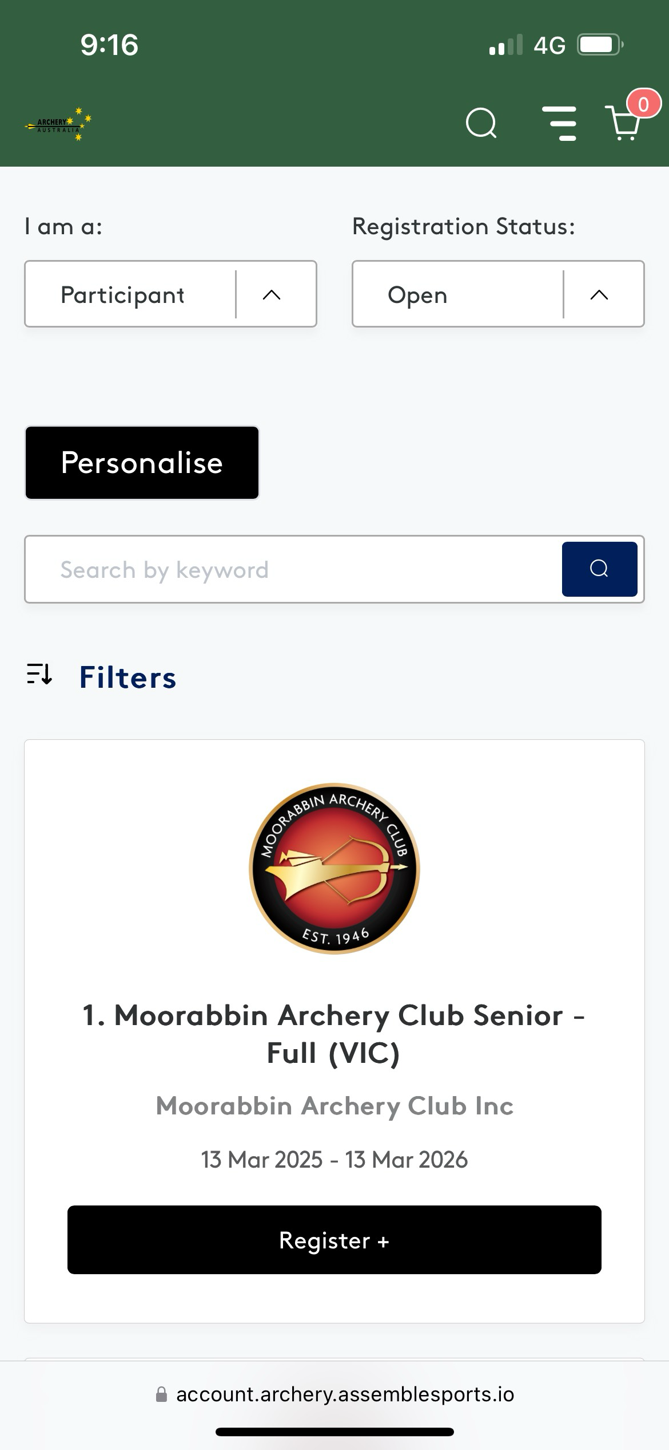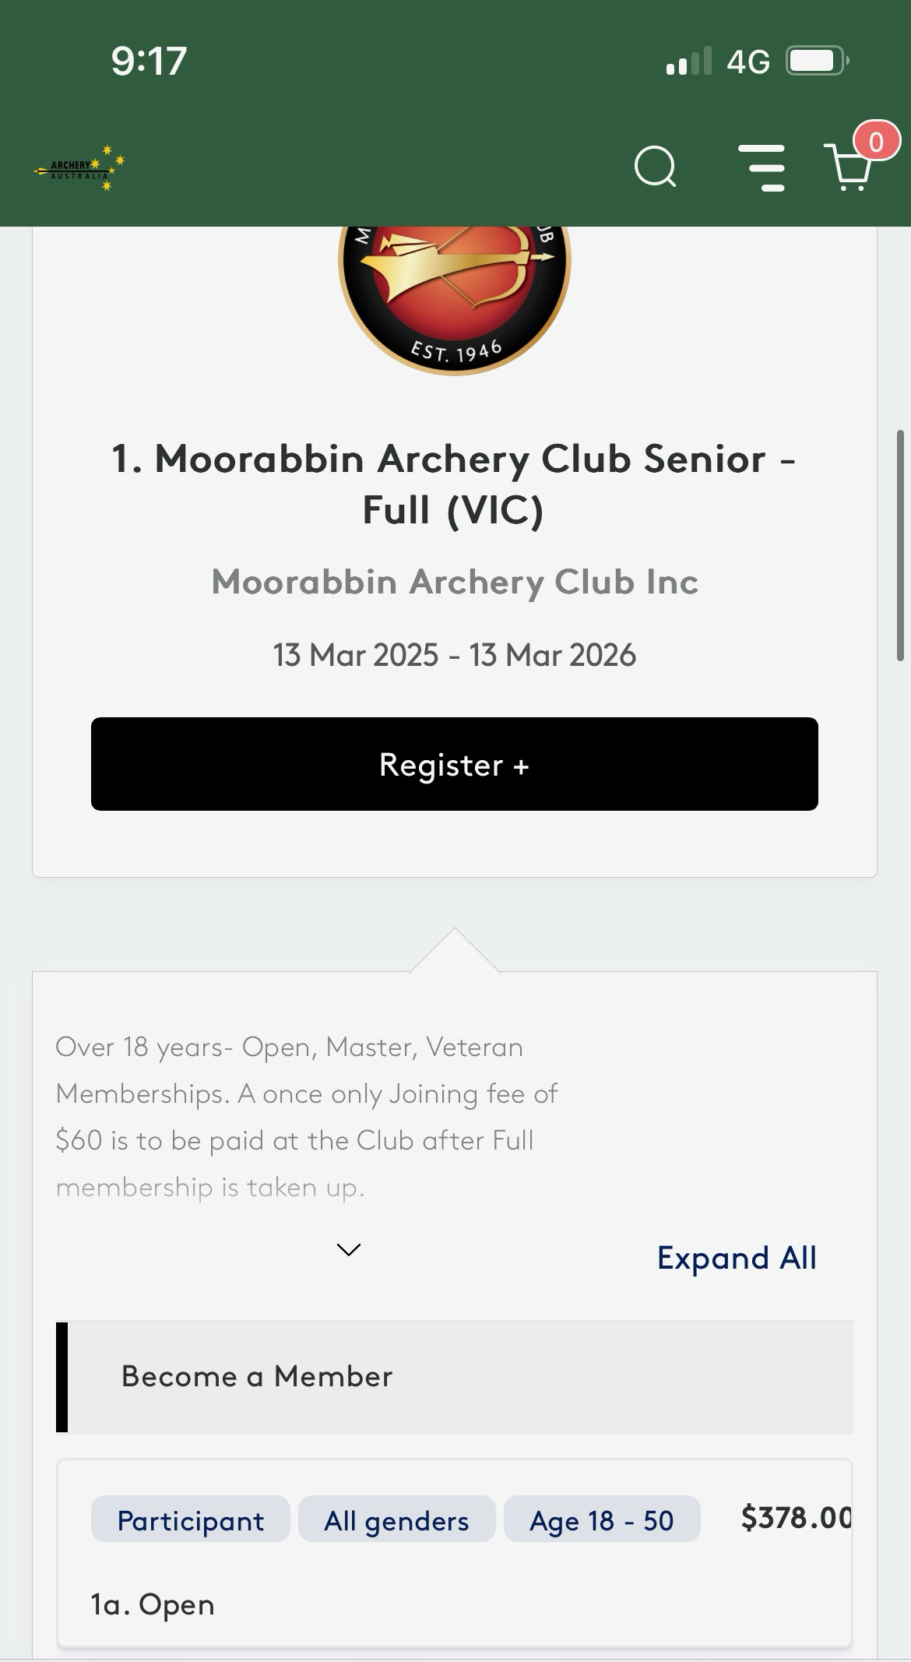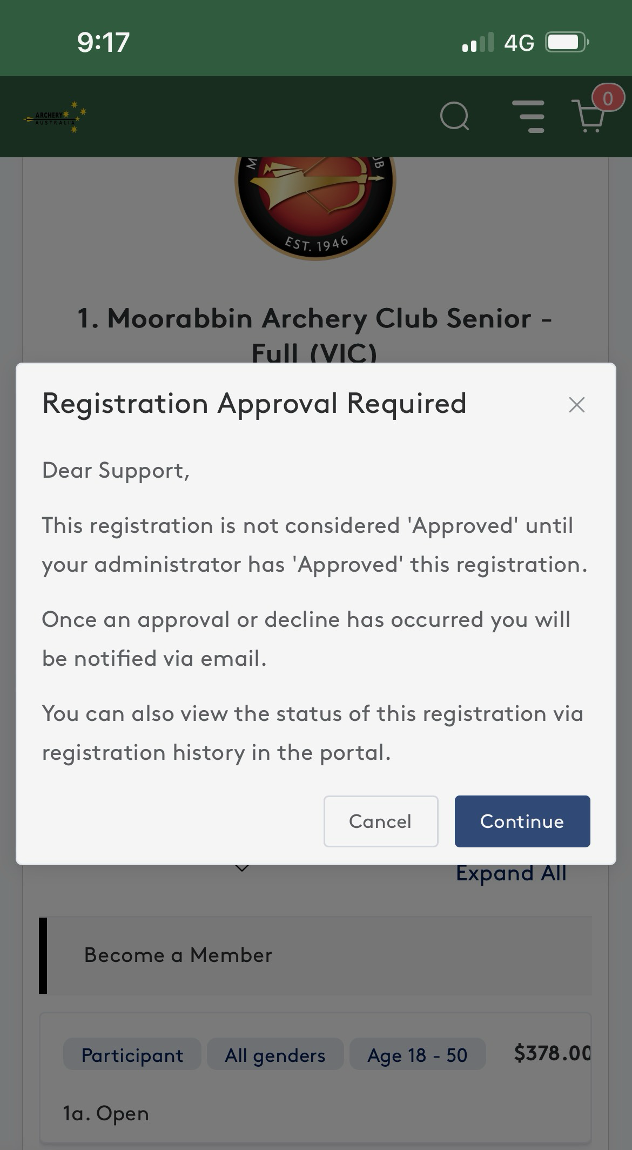

- Once you have continued into the membership registration you will be required to confirm / fill in any relevant / additional information that the club desires. From there you will be able to make payment and become a member, or wait until your membership is approved by the club (you will receive relevant email updates in this case).
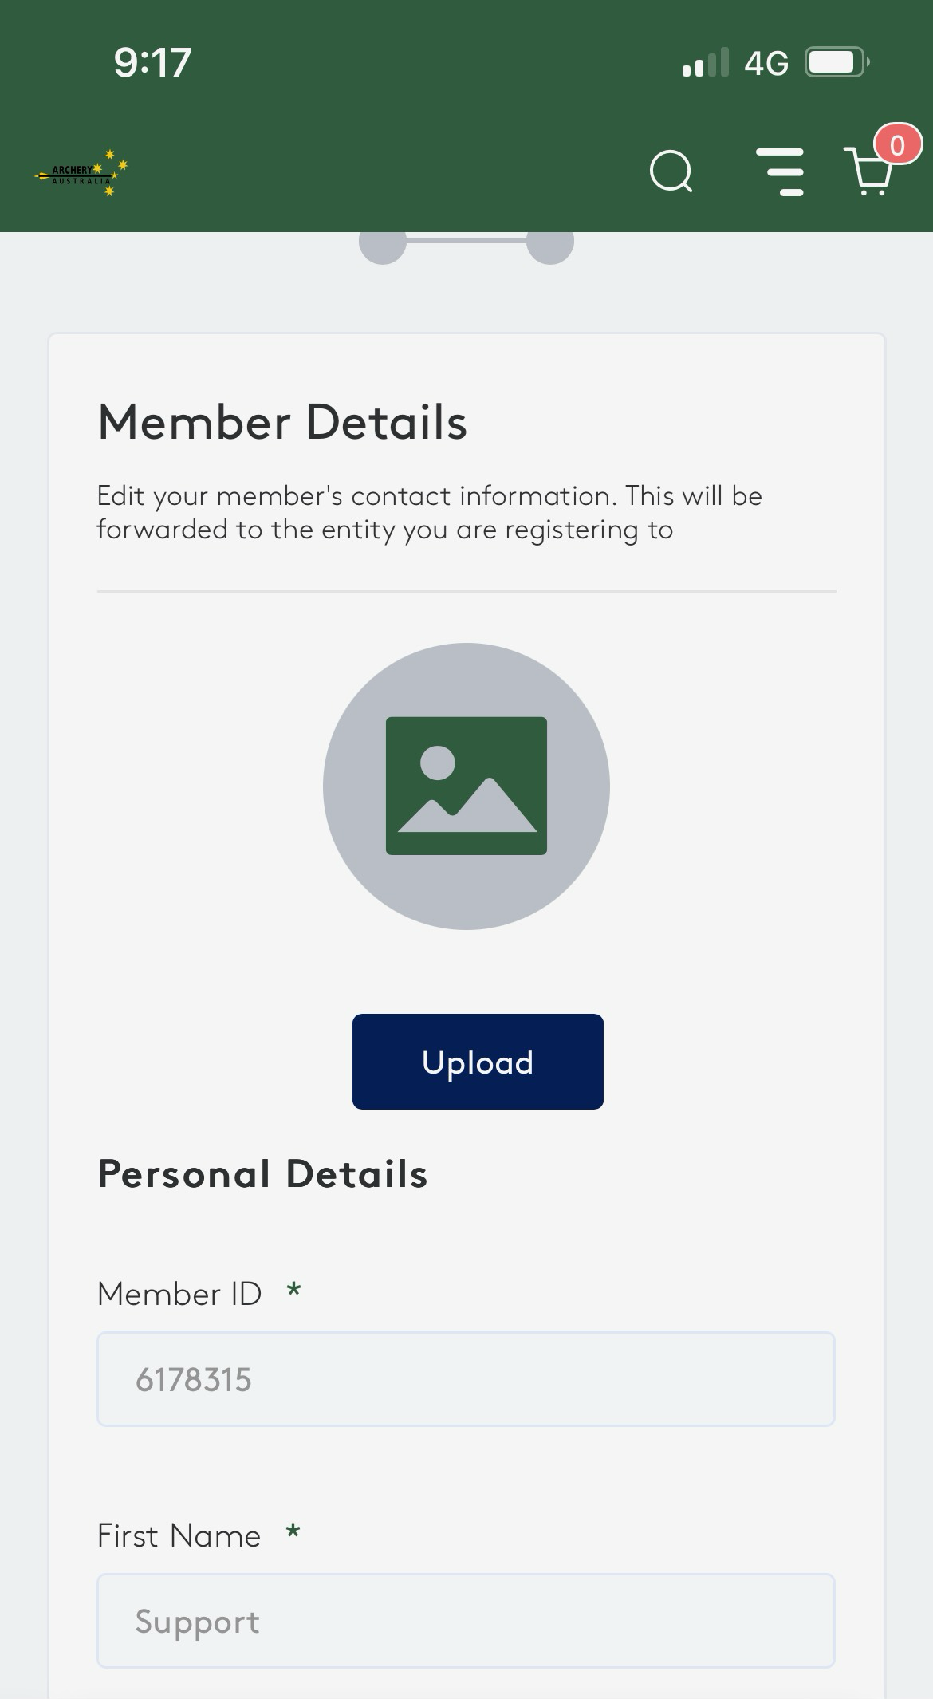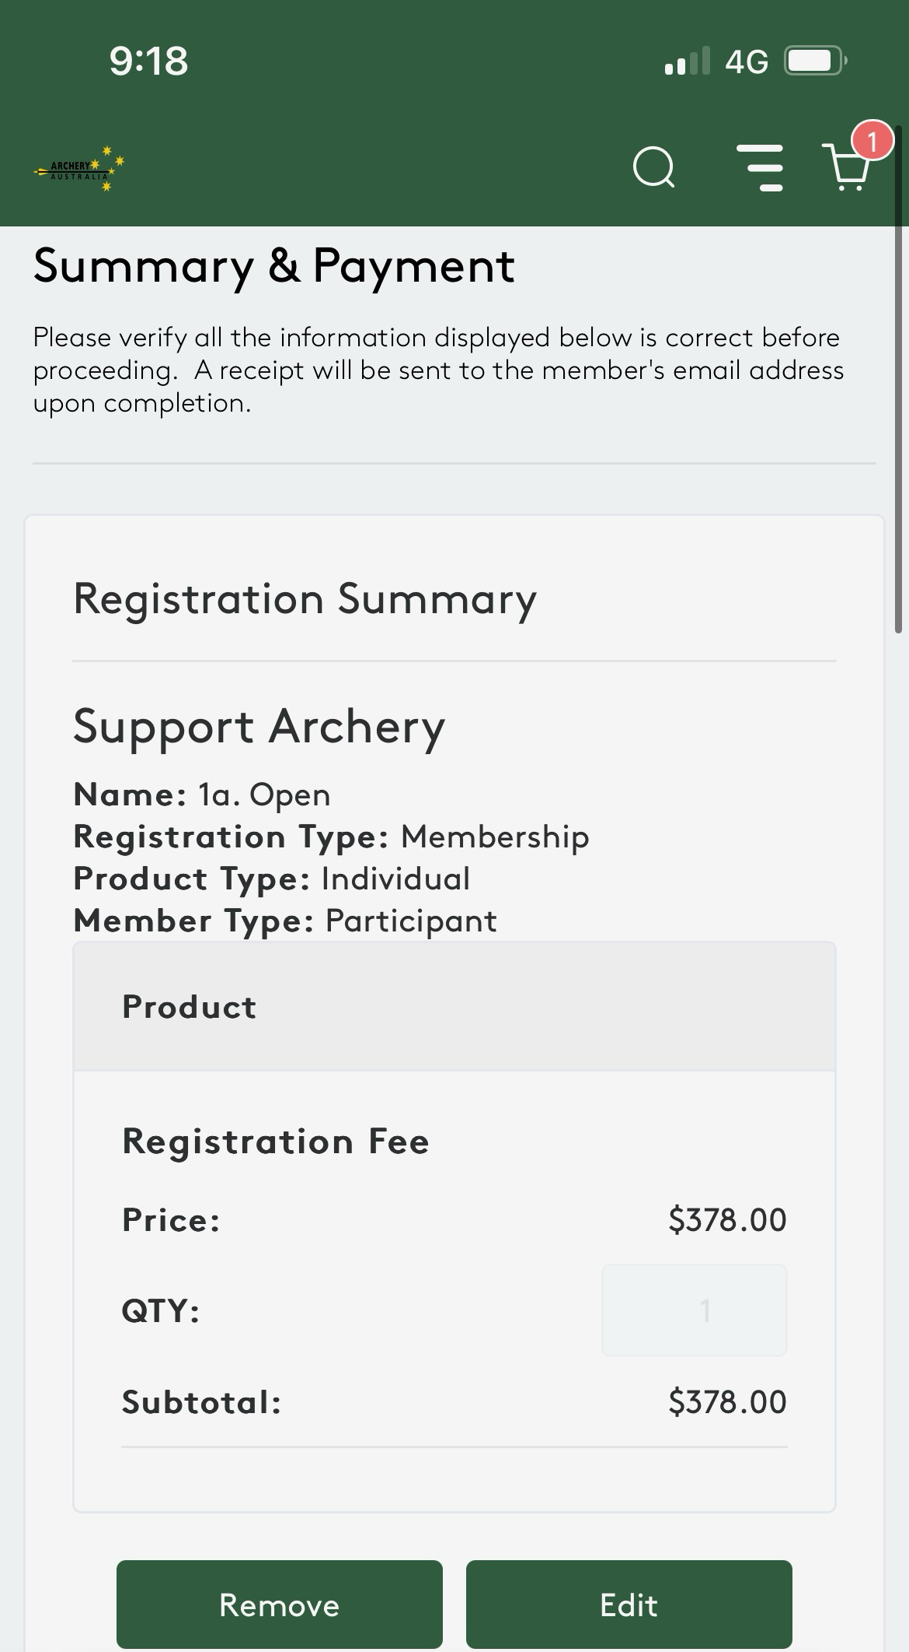

Casey Isles
Database / LMS Administrator
If you have any questions for Assemble support and assistance, please contact:
Archery Australia
E – Support@archery.org.au
P - +61 451 933 850

