Assemble Sports Creating an Account
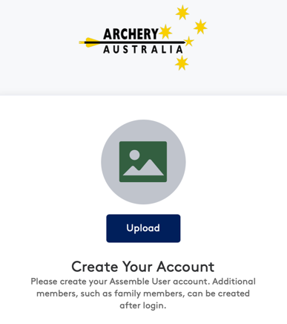
- Go to http://account.archery.assemblesports.io/sign-up, fill in your account details and click “Create Account”.
- Please note you only need one Assemble account per family, multiple members can be added to the account later.

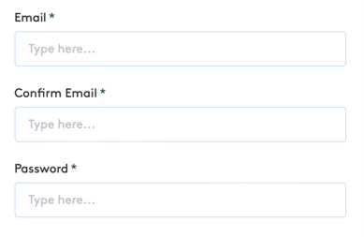

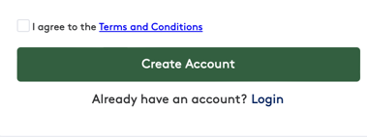

- Once the account has been created you will need to verify your email address. Check the email inbox that you entered into your account (check junk / spam folder). Open the email and click the “Verify Email” link to activate your account.

- From there you can then login to your Assemble account and apply for a beginner course if you are new to archery, or register for a membership if you are a returning member. Please refer to https://archery.org.au/membership-2/ for guides on how to register for a membership, event and other Assemble guides.
If you have any further technical assemble questions, please contact the below contact:
Casey Isles
Database / LMS Administrator
Archery Australia

E – Support@archery.org.au
P - +61 451 933 850

