Designing Assistive Devices for Para-Archery

Introduction
Archery clubs aiming to support para-archers should equip themselves with knowledge on the six assistive device types permitted under Paralympic rules. Each device must comply with regulations ensuring fairness and safety, available at https://extranet.worldarchery.sport/documents/index.php/Para/v1.1_2023_Adaptive_Equipment_Resource_Guide.pdf

Below are descriptions, design considerations, and practical steps for implementation.

1. Release Brace
- Overview: A mechanical release aid mounted on a custom block, hinged to a back or torso brace. Activation may be achieved through biting or mechanical triggers.World Archery
- Design Steps:
  - Assessment: Identify individual archer’s needs—e.g., upper-limb mobility or grip limitations.
  - Component Sourcing: Obtain adjustable braces, release mechanisms, and hinge hardware.
  - Customization: Fabricate a block to attach the release to the brace; design hinge movement that aligns with the bowstring.
  - Activator Option: Many archers use a bite mechanism (e.g., a clothes peg) linked via cable—source safe materials.
  - Safety & Comfort: Ensure padding and adjustability; no sharp edges.
- Implementation Tip: Test with the archer to refine tension and comfort before competition.

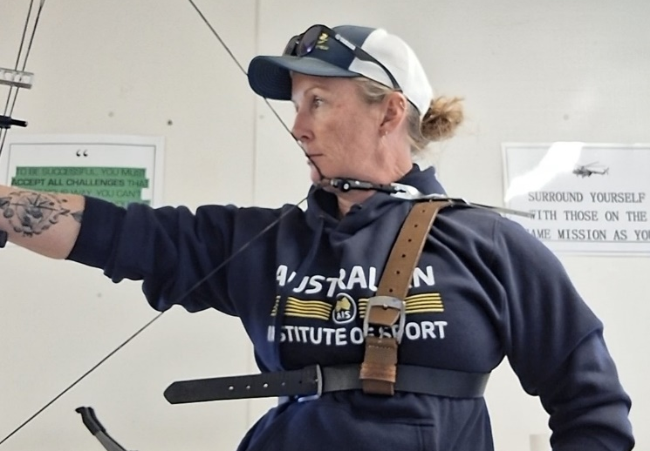

2. Wheelchair (Modified)
- Overview: A standard wheelchair adapted to comply with para-archery specifications—particularly back and side heights that do not confer extra stability.World Archery
- Design Steps:
  - Review Rules: Confirm maximum allowable backrest and side height under current regulations.
  - Modify Chair: Trim or replace components exceeding allowed dimensions.
  - Stability Check: Ensure the modifications do not compromise safety or chair integrity.
  - Practice Run: Test with archer in various shooting positions; adjust as needed.
- Implementation Tip: Keep portable tools/spare parts on-hand for last-minute adjustments prior to events.
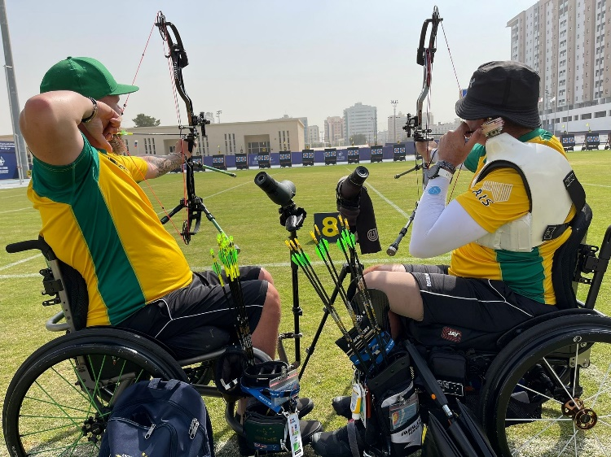

3. Stool (Seating Aid)
- Overview: A simple stool for archers who cannot stand or balance but don't need a wheelchair.World Archery
- Design Steps:
  - Assessment: Confirm classification permits seated shooting using a stool.
  - Select Stool: Choose a height-adjustable, stable model suitable for outdoor ranges.
  - Safety Enhancements: Add non-slip feet, straps or anchorage points if needed.
  - Test Seating: Ensure correct alignment for sighting and shot control.
- Implementation Tip: Practice transitions between sitting and standing if applicable to competition requirements. And consider a design that will work on multiple surfaces, such as grass, astro-turf, concrete etc.

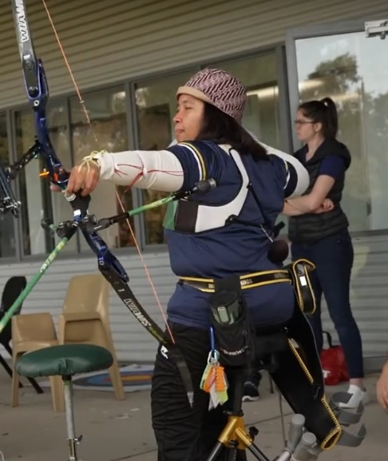

4. Prosthetic (Bow-Holding Aid)
- Overview: Prosthetics replacing limbs must mimic human joint movement—not exceed physiological stability.World Archery
- Design Steps:
  - Consult Prosthetics Specialist: Ensure the device replicates natural joint flexibility.
  - Integration with Equipment: Design attachment points so the prosthetic interfaces securely with the bow.
  - Quick Adjustment Feature: Consider allowing the archer to slip their arm into the prosthetic just before shooting, as done by some competitors.World Archery
  - Balance and Weight: Ensure weight distribution promotes the best performance for the archer.
- Implementation Tip: Include quick-release mechanisms for comfort and alignment checks.

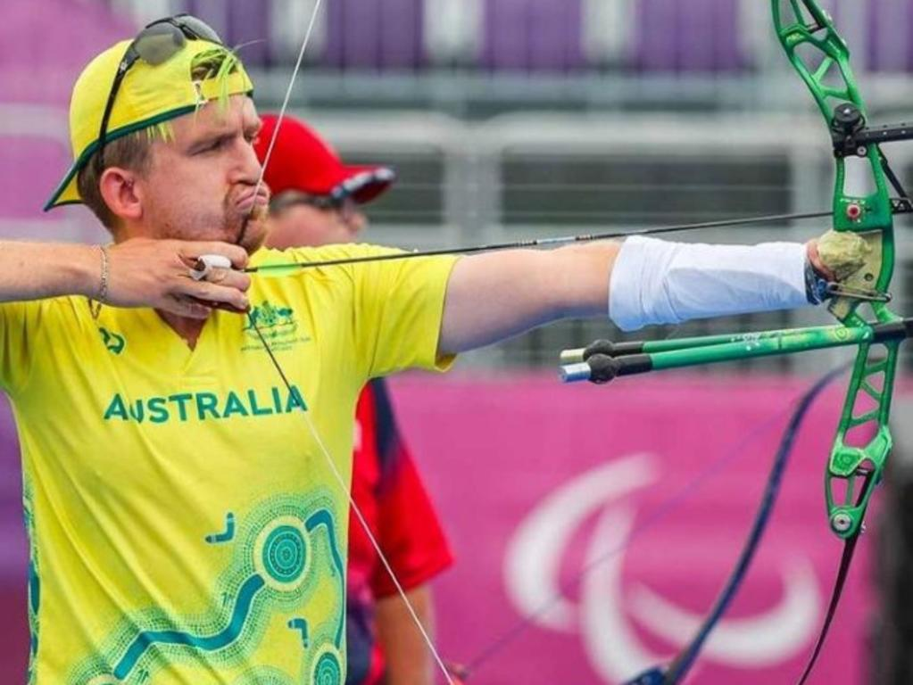

5. Mouth Tab
- Overview: A fabric tab bitten on and pulled to release the string—used in recurve when mechanical releases are restricted.World Archery
- Design Steps:
  - Fabric Selection: Choose high-durability, non-abrasive material (e.g., reinforced microfiber).
  - Attachment: Secure just below the knocking point to ensure clean break.
  - Bite Interface: Make a comfortable, safe section for the archer to grip with teeth.
  - Release Mechanics: Ensure the archer can pull and release cleanly using mouth movements.
- Implementation Tip: Confirm archer's dental and physical comfort, practice slow draw-release cycles in training.
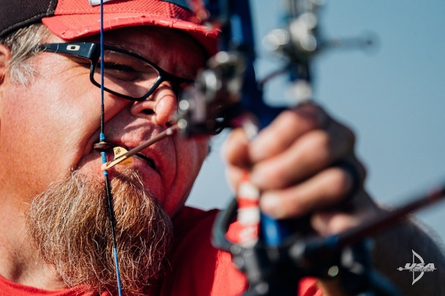

6. Elbow Strap (Arm-Mounted Release)
- Overview: A release aid strapped to the arm or elbow, activated via triggers, tension, or hinge mechanisms—used when hand function is limited.World Archery
- Design Steps:
  - Assess Limb Function: Determine where on the arm the release can be stably mounted.
  - Select Strap System: Use adjustable, padded straps to secure a release aid safely.
  - Activate Mechanism: Could be triggered by a finger, wrist movement, or mechanical hinge.
  - Fine-Tune Tension: Adjust for secure but comfortable engagement.
- Implementation Tip: Trial-and-error testing with the archer is essential to dial in sensitivity and comfort.

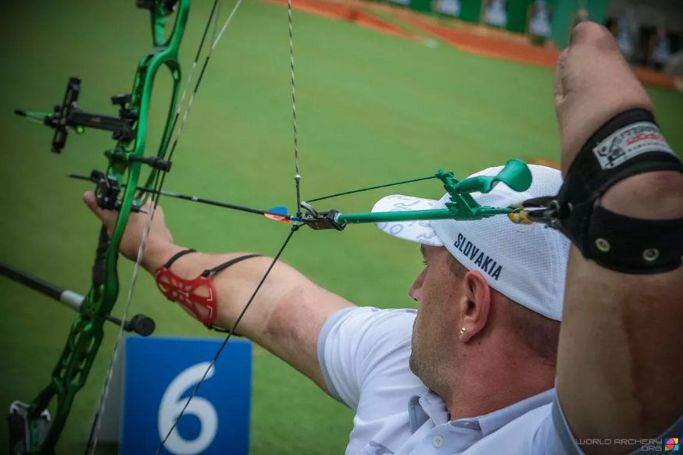

How to Make Modified Wheelchair Supports

A back-rest for wheelchair archery can be made cheaply using materials from everyday hardware and online stores. The main structure is created from a thin aluminium sheet (available from Bunnings) that is bent to fit around the archer’s torso. This is then reinforced with carbon fibre cloth and epoxy resin (from Amazon) to stop it from bending. Hollow metal poles from Bunnings can be added to connect the back-rest to the chair, and if the chair doesn’t allow direct attachment, clamps from Amazon can be used. Padding, such as a yoga mat from Kmart, is added for comfort. When shaping and sizing, make sure the backrest sits at least 11 cm below your draw arm at full draw, and side supports don’t extend more than half your body’s depth.

Once the aluminium and carbon fibre are shaped and set, the poles or clamps are attached, and foam is added where extra support is needed. You’ll need basic tools like scissors, ruler, mixing bowl, and a respirator mask, as carbon fibre and resin require safe handling and drying time (about one day per layer). Typically, 2–3 layers of carbon fibre are enough. While the finished product doesn’t need to look perfect, the goal is strong support and minimal movement to give the archer consistent stability. Later, the design can always be refined, but this low-cost approach provides a simple and effective solution.

Ensure that all adjustments comply with the adaptive equipment resource guide. https://extranet.worldarchery.sport/documents/index.php/Para/v1.1_2023_Adaptive_Equipment_Resource_Guide.pdf

